Script for Figures 2021 Explanation

%Figures 2A to 2D are very simple, no stats involved so they are not

%considered here

Note 1.1. Figure 2E. Line 7. MUA change plots

This Figure works with all neurons that where modulated (Decrease, Increase). The different arrays are expressed in percent change of the FR. For this I divided the FR in the saccade trials by the mean firing rate (mean of distributions of FR of 400ms duration ‘averageFiringRates’). The arrays consist then of cells x change value.

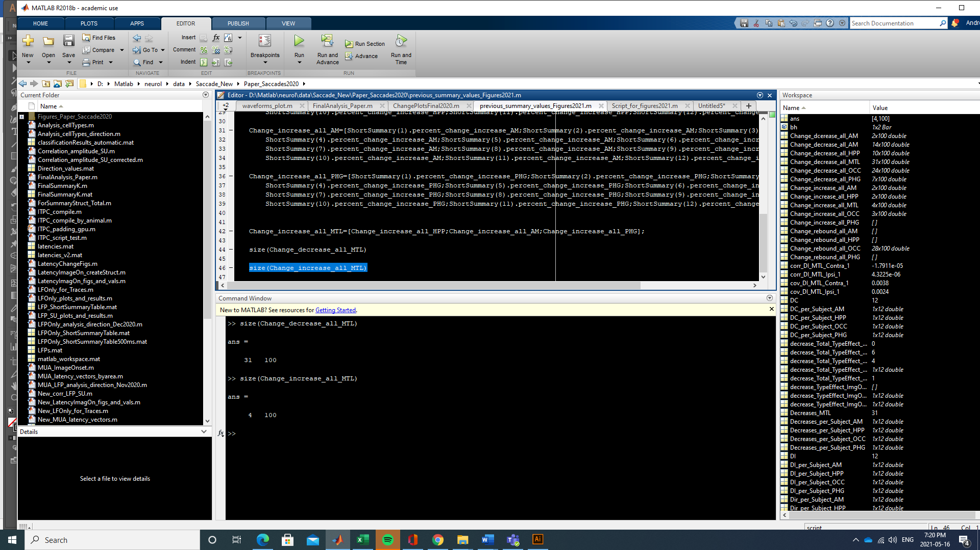

Then I calculate the mean of that and get standard error. numel_mean_Change_decrease_all_MTL=size(Change_decrease_all_MTL,1)

mean_Change_decrease_all_MTL=mean(Change_decrease_all_MTL)

SEM_Change_increase_all_HPP = std(norm_singal_Change_increase_all_HPP)/sqrt(numel_mean_Change_decrease_all_MTL);

Note 1.2 Insert Figure 1.2. Line 28, Latencies

For that I used the Probability Density ('PDF_Saccade') that consists of an array from 1 x 100 samples. This is then not in ms exactly. So I used that array and interpolated using imresize (<https://www.mathworks.com/help/matlab/ref/imresize.html> ) to 5000 to get an array in “ms”.

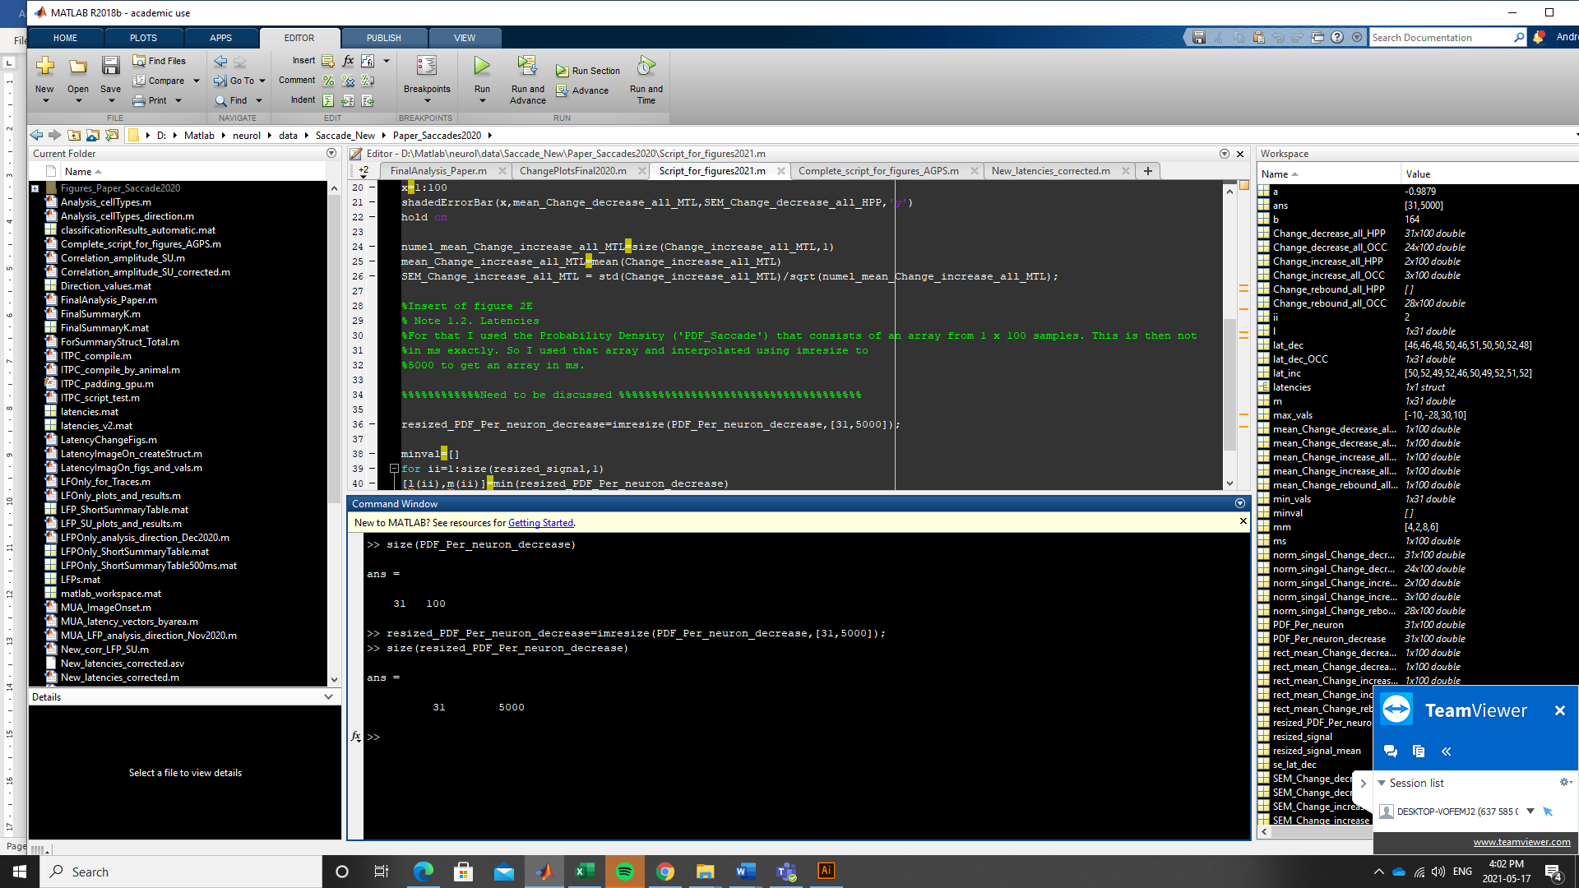

**** Important, I was reading about this yesterday. In the moment it seemed to be a correct way to do this, but there might be better ways to interpolate… and it will not take a lot of time to do it… so if you know of any other way, let me know.